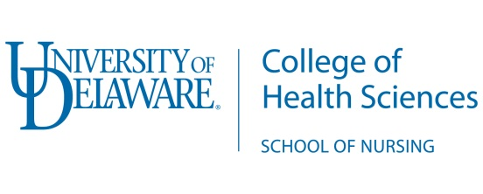
Student Employment Verification Form

Dear Prospective Graduate Nursing Student,

Prior to enrollment in graduate nursing courses at the University of Delaware, students working at an Affiliated Institution must allow UD School of Nursing to obtain employment verification. Once employment has been verified, the student will be awarded the Graduate Nursing Scholarship Tuition rate.

Additionally, it will be your responsibility to notify the University of Delaware School of Nursing if your employment status changes while enrolled in the program.

UD Nursing contact is: ud-gradnusing@udel.edu

Please fill in the requested information below with your current place of employment.

Name of Facility ________________________________________________________

Facility Address _________________________________________________________

_________________________________________________________

************************************************************************
I _________________ authorize the University of Delaware, School of Nursing to contact the above facility to obtain employment verification.

Student Name (please print)____________________________________

Student Email ___________________ Student Phone ______________________

Student Signature ____________________________________________

Date_______________________________________________________
************************************************************************
Please fax completed form to School of Nursing @ (302) 831-2382
Or mail to: University of Delaware School of Nursing, 25 North College Ave.,
Room 349 McDowell Hall, Newark Delaware 19716

